**St. Petersburg versus Tampa**

**Which will have the next great Craft Brewery?**

Cassandra Currier

May 27, 2021

1. **Introduction**

**1.1 Background**

The Craft beer industry is a growing market. According to the Brewers Association, U.S. Beer sales volume growth for 2019 overall was down 1.6% while the craft segment was up 3.6% and imports were up 1.8%. The craft beer market is valued at $29.3 billion and occupies 13.6% of the overall beer market. Interestingly the overall beer production aligns with the overall volume growth for all beer and for craft beer. In 2020 we saw these numbers decline. The overall beer market was down 2.9%, craft down 9.3% and imports up 0.6%. The change in these numbers was largely due to the impact on closed business during the pandemic and most sales being package sales and not on premises consumption. We should expect to see the craft beer market again have growth for 2021.

At 368, Florida currently ranks 7th in the nation for number of craft breweries. While this is a large number of breweries, Florida ranks 41st in breweries per capita, with only two breweries per 100,000 adults aged twenty-one or up. Craft breweries have a large impact on Florida’s economy. The state ranks 5th with 3,818 million dollars (2019 data) added by the craft brewery industry. In terms of beer production, the state ranks 4th producing 1,213,358 barrels based on 2020 data.

**1.2 Problem**

Tampa Bay is a large metropolitan area consisting of several cities. The primary two cities are St. Petersburg and Tampa. If someone wanted to open a brewery in the area, they would want to do so in the city that would allow for best success of the brewery.

**1.3 Interest**

This would be of interest to a couple different groups possible. A business owner looking to expand their portfolio and open a craft brewery. A current craft brewery looking to expand and open another location. An individual with a hobby and a dream to open their own craft brewery.

1. **Data acquisition and cleaning**

**2.1 Data Sources**

Data was pulled from two separate sources. The brewery statistics and brewery styles were pulled from the [Brewers Association](https://www.brewersassociation.org/) website. Unfortunately, specific data as to the number of barrels produced by each brewery is not available to the general public and only to their members. Additional data was pulled from Foursquare. This included the brewery names, locations, tips and ratings for each brewery.

**2.2 Data Cleaning**

Data was downloaded or scraped from Foursquare to multiple tables. This data was then combined by city and the additional columns for Style, Tips and Ratings were added and filled in.

Some of the data for ratings were missing from the breweries. For those, I took the mean of the ratings for the other breweries in the same city. The breweries with zero tips were just left at zero.

Once the tables were combined a numpy array was created with only the useful numerical data and the cities were given dummy variables.

**2.3 Feature Selection**

The primary data pulled from Foursquare for the breweries were longitude, latitude, type of venue, name of venue, ratings and tips.

All this information was used at some point in analysis. The location data was used for mapping the breweries. Once the mapping was completed, those columns were dropped from the table to create the array.

1. **Exploratory Data Analysis**

**3.1 Correlation between Ratings, City and Style**

A correlation test was run to determine if there was a relationship between any of these three aspects. There was a week but positive correlation between the city and style of the brewery. There was a larger negative correlation between the ratings and the city and style of the brewery.

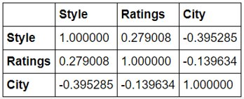

**3.2 Value Counts on Style of Breweries**

Style of breweries is defined by the [Brewers Association](https://www.brewersassociation.org/statistics-and-data/craft-beer-industry-market-segments/#Micro). The styles that St. Petersburg and Tampa have are the following: Taproom, Microbrewery, Brewpub and Regional Brewery.

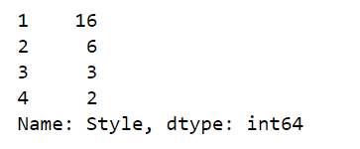

**3.3 Regression Plot**

The regression plot was run to see if there was a relationship between the number of tips and the style of brewery. There was some useful information gleaned from this. If you have a Regional brewery you will indeed have some tips provided for you location. Tap houses do not always have tips provided but if they do, the number is not large. The microbrew locations do have the largest range of tips from zero to one hundred and seventy-four. Brewpubs do not always have tips and if they do, it is not a substantial number.

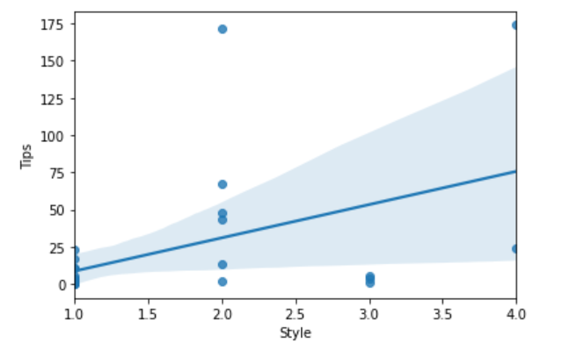

1. **Predictive Modeling**

**4.1 Classification models**

The classification model of K Nearest Neighbors was used for this data set. If someone is to open a brewery, this model would be able to predict what type should be opened in relative location to the other breweries already established.



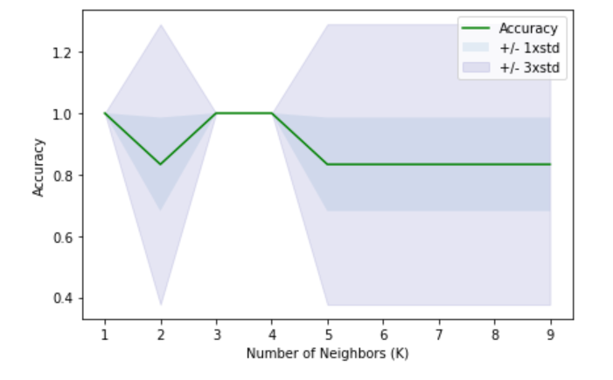

1. **Conclusion**

Based on the data available and the analysis of the data, the next brewery that should be opened should be a Tap Room. Based on ratings and tips, this should be located in Tampa.

1. **Future Directions**

Any new or current tap house should consider in their business plan a path towards becoming a regional brewery. These breweries have higher ratings and more tips than other locations. As a Tap Room grows and gains in popularity it should expand towards a microbrewery and then eventually a Regional Brewery. The need to become a Brew Pub is not necessary as most of the current breweries are not that type and are still successful and well liked with average ratings overall of at least 8.4.